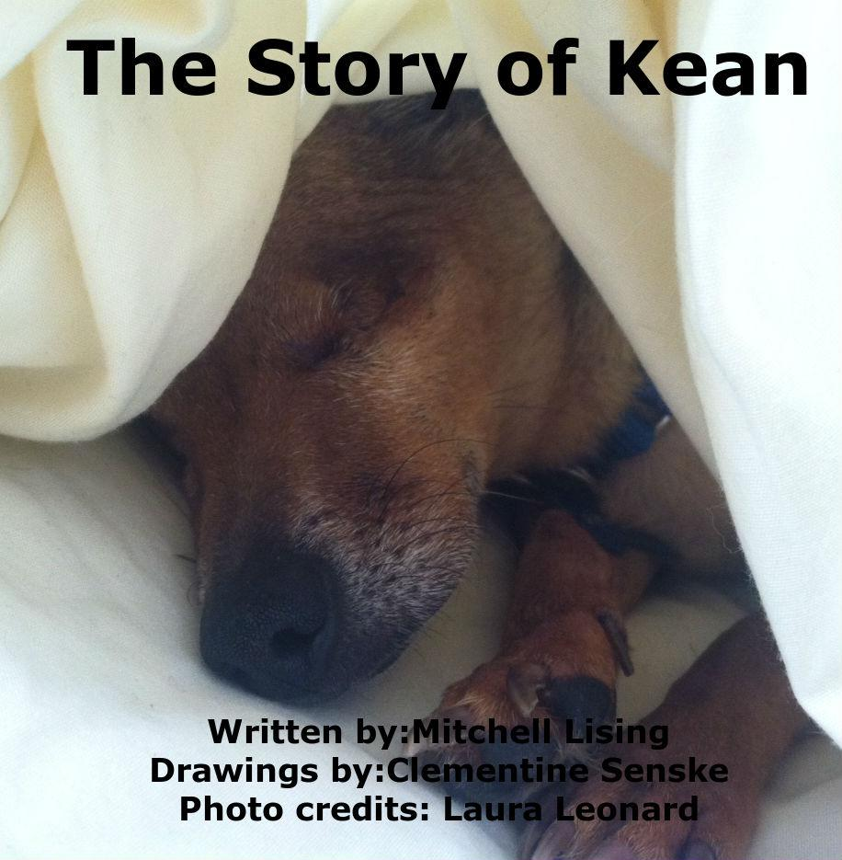

“A dog is the only thing on earth that loves you more than he loves himself.”
― Josh Billings

This book is dedicated to The San Diego Humane Society and the animals who have stayed in the shelters, waiting to be adopted. This story could not have been made possible without their help and the help of Kean and Laura.

The Story of Kean
Written by Mitchell Lising
Illustrations by Clementine Senske

Additional photography provided by Laura Leonard and by the San Diego Humane Society

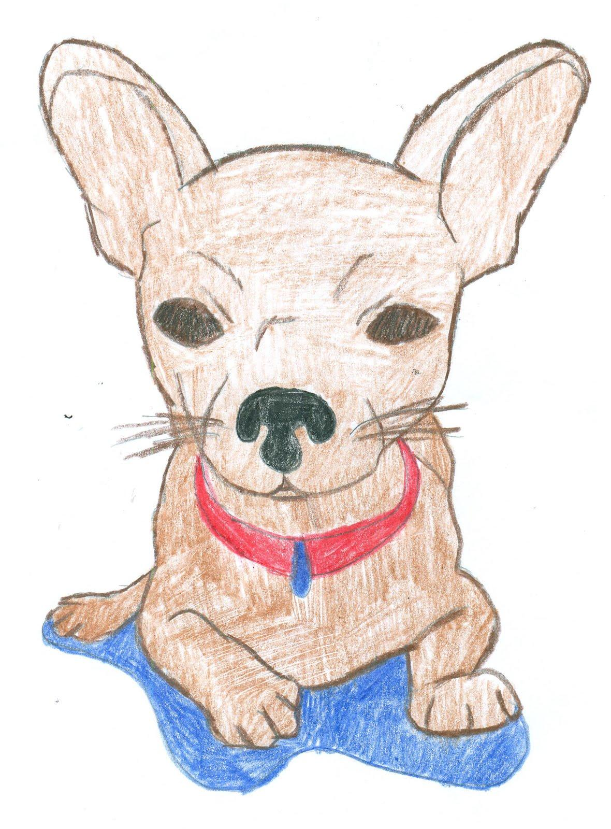

Hi, I’m Kean. I live in a warm house with my human, Laura, and two cats. I live very comfortably. I have a cozy bed and, a yard rich with grass,where I like to feel the warmth from the sun. However, my life was not always a lap of luxury.

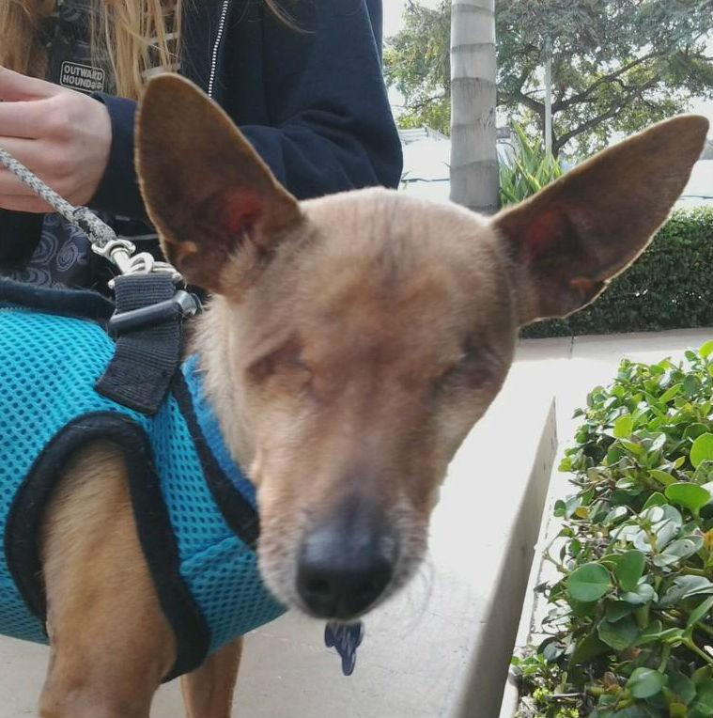

The love I know today used to be present only in my dreams…

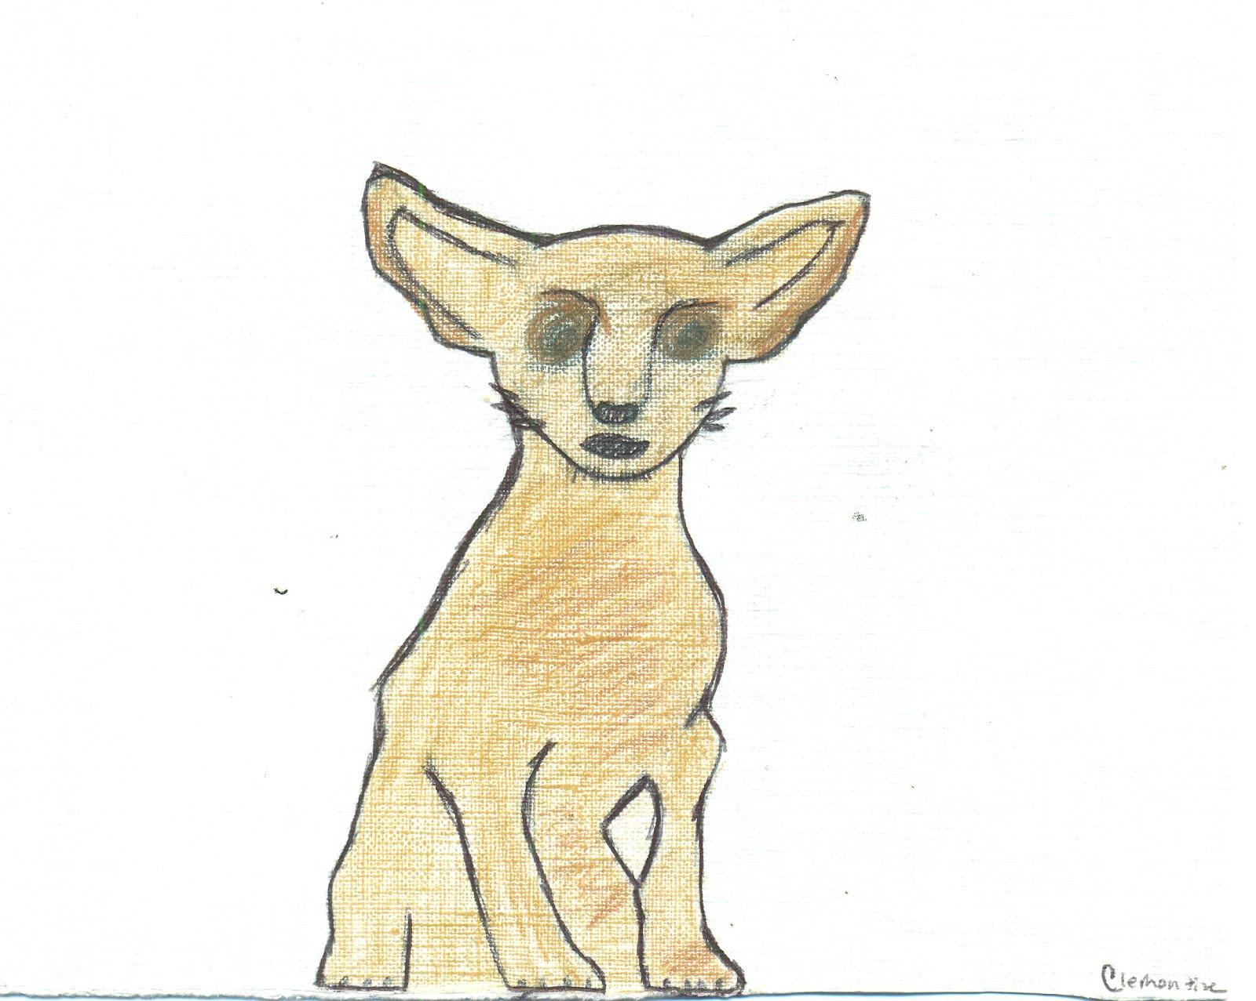

I am left all alone in the freezing night air to fend for myself. I look for some place to hide or someone to take care of me. I’m scared, alone and sick.

I search and search, but its all blurry shapes that scare me. The sickness has crept into my eyes and effects my vision. But I hear spraying water and shouting voices. My fear is becoming overwhelming and my eyes ache.
“Oh, look its a Chihuahua! You look so cold! And something seems to be wrong with your eyes, poor thing!”
Suddenly a woman scoops me up. “You look like you belong to someone. What are you doing in the car wash?” Before I know what to think the human carries me towards her car. “Don’t be afraid little buddy. I’m going to take you to a safe place that will take good care of you.”

The human continues to try to reassure me, but I am still afraid of the unknown. The woman gently sets me in the seat next to her. I begin trembled while she drives.
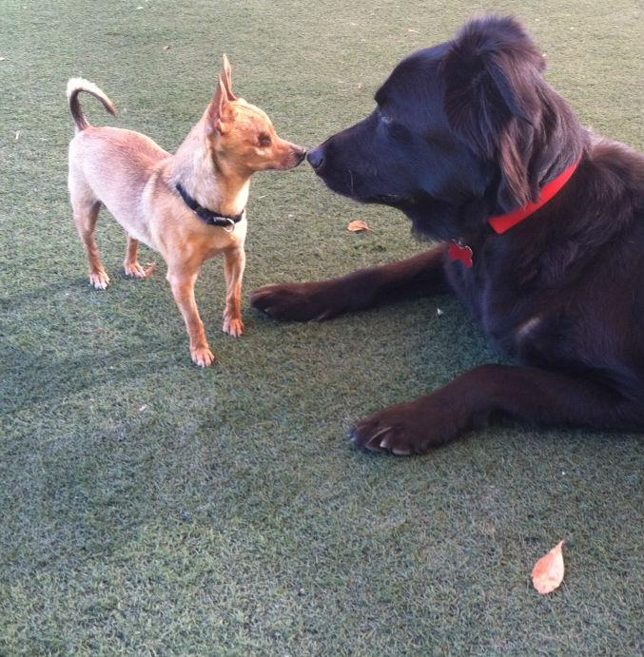

Soon we arrive at a large unfamiliar building. It all feels so surreal. I am carried inside the building and put on a high table. I see shadows of more people leaning over me. They begin poking and prodding at my cold and trembling body. My eyes sting, they burn. The pain is almost too hard to bear. I squeeze my eyes shut hoping it will block the pain. Until one of the shadowy figures pick me up and carry me through heavy swinging doors. My eyes are still throbbing, but the pain seems to grow more and more distant and I find myself drifting off to sleep.

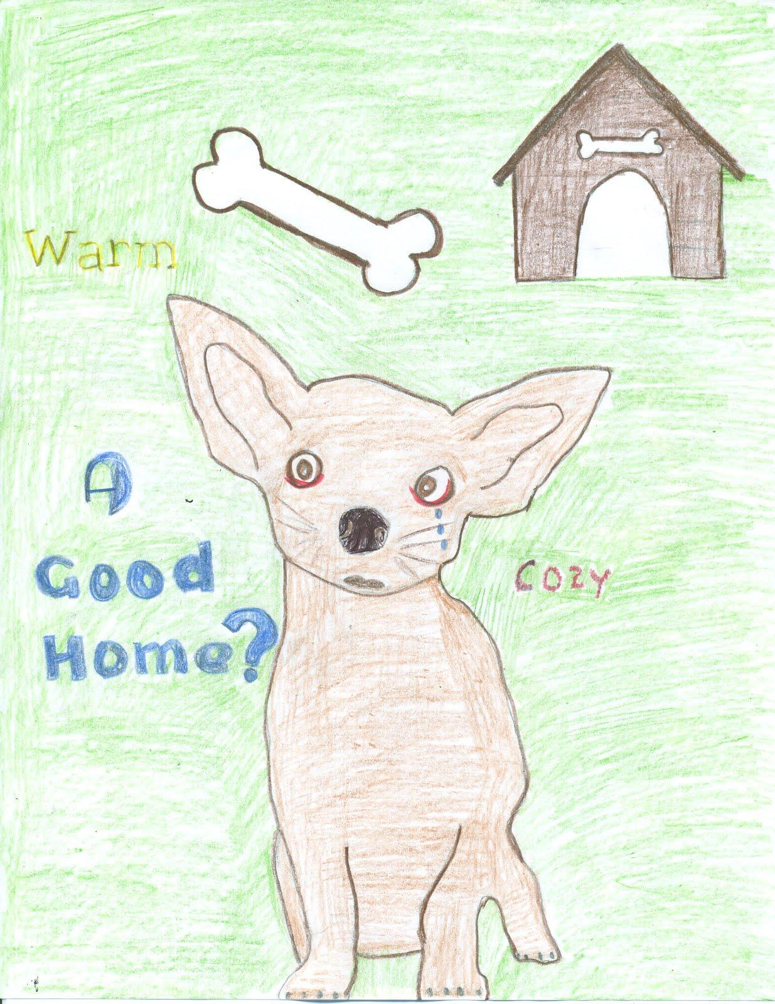

I must still be groggy from my nap. I can hear dogs barking and smell the fear everywhere, but I’m confused because it is still dark. I’ve never experienced darkness quite like this. I stand up wobbly, try to walk. I step right into a bowl of cold water. I try to turn but my other paw lands in my food.
What was going on? why couldn’t I see? I started barking for the humans to help me. But no one came. They can’t distinguish between my voice and the other relentless barking and crying that fills the building.

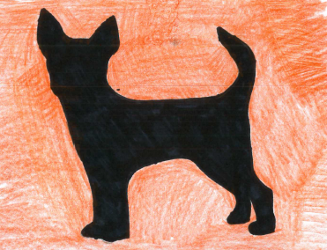

Eventually I become weak from my unanswered cries. I become hungry and started sniffing for the food bowl. Eventually, I find it. I take a bite of the kibble. I suddenly feel a sharp pain! My teeth are gone! Again I keep barking and barking. “Help me.”
Finally, I sense the presence of a human and I hear a soft voice say, “You’re awake! You must be so confused. They had to remove your eyes and your teeth, because they were infected but you're going to be ok. Everything is ok now. You’re safe.”

A week has passed and I’ve heard many humans pace by my kennel, but they never stay for long. Until one day a new human arives. Her name is Laura. I have heard other people call her that around the building, but I never encountered her this close up. “Hi, buddy!” she says, “Aren’t you adorable? How about you come home with me? I’ll take great care of you.” At that moment I felt a sudden burst of genuine happiness.

She brought me to her house. I felt something soft beneath my paws. The aroma of the home smelled like a big pot roast being cooked. I began to tentatively explore bumping into many things like tables and chairs. But eventually I get used to the layout of my new surroundings, memorizing the pleasant smells and lovely textures. It feels like home.

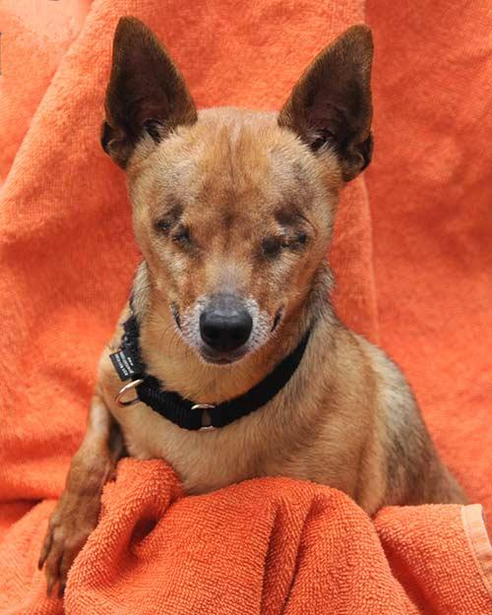

I am almost never alone anymore. Laura sometimes calls me her “Little Man”, even though I clearly know that I am very big. Most days Laura takes me to visit with a lot of small humans. They have sticky hands and excited high pitched voices, but I can feel their love in the gentle way they pet me. They will never hurt me.

Still, sometimes I need a break. I withdraw from their reaching. Laura sees me and scoops me up as she begins to teach her lesson about what dogs like me, have been through. “We need to take care of them and be dedicated to take on the parenting role,” she explains, “ because everyone deserves to receive and give love.”

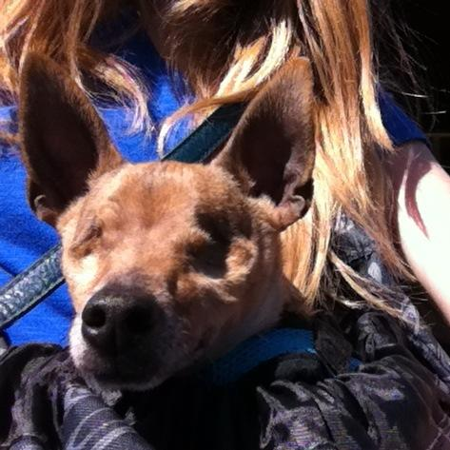

Since I cannot see, Laura helps me. She carries me around in her special designed bag just for me. She keeps me safe and warm. When I’m in her bag I do the “Chihuahua shake,” which always makes her happy. Most people think that when a Chihuahua shakes its always a sign that they are scared, but they are wrong. Chihuahuas do shake out fear, but it is also a sign of love and happiness toward their owner when they are near them.

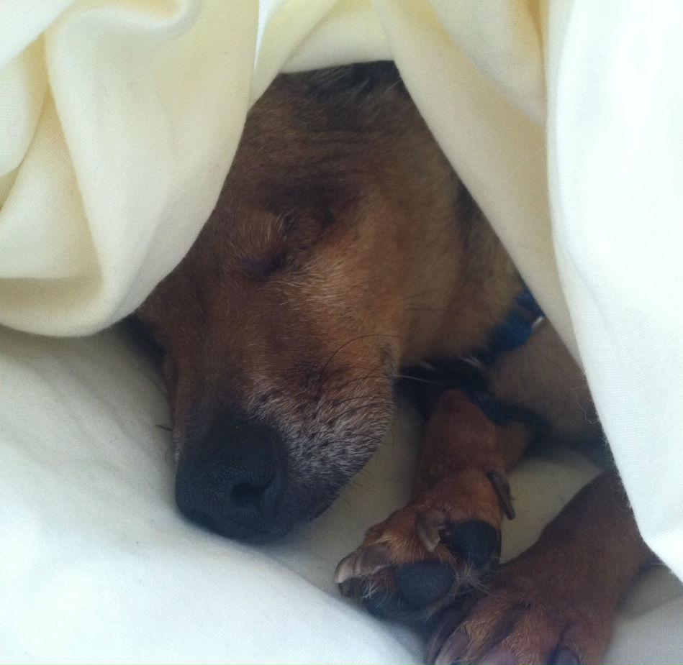

I never let my loss of sight get me down. I have learned to use the rest of my senses, like my smelling and hearing, to the best of my ability. Laura once told me a story about how my old owner must have tried saving my eyes and teeth without seeking the help of a veterinarian, but couldn’t do it. Their home remedies damaged my eyes and teeth beyond repair. Many people worried that I was never going to be adopted, but Laura saw the beauty in me.

From this day forward I will be loved and cared for by Laura. I have found my forever home.

In the U.S. each year about 130,000 dogs are abandoned, most of them end up in shelters to begin the long wait for a good home. Some get homes. Other do not. Some dogs are abandoned because of a simple lack of commitment to them as a valued part of our families. Before considering bringing home that cute little puppy, consider the responsibilities you are accepting and the consequences of abandonment.
This story could not have been made possible without the San Diego Humane Society and the help of Kean and Laura, his caring human. For more information on adopting a shelter animal go to http://www.sdhumane.org.

