Fortress of the Immaculate Conception
This structure was built to protect locals in neighboring Granada from pirate attacks.

When visiting Nicaragua it is important to learn about its history and their way of protecting their culture and people, so visit other monuments!

The fortress of the Immaculate Conception is also one of the main tourist’s attractions of this wonderful country!
Fun fact: The Fortress of the Immaculate Conception was constructed in the late 17th century!

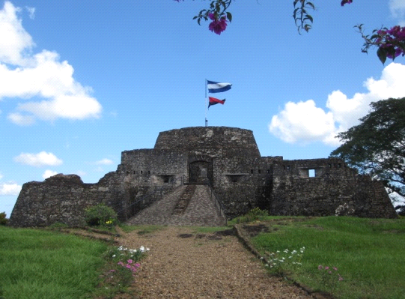
Pacific Lowlands

The Lowlands is one of the most luxurious but also dangerous attractions.
Although it houses beaches and resorts that are very luxurious it also neighbors 40 volcanoes, with some still active, and its ashes fertilize the land.
It also includes a migration of Scarlet Tanagers that migrate through Nicaragua, as you see the bright red feathers across the sky.
“Let’s watch the bird migration!”
“We should stay at the resort!”
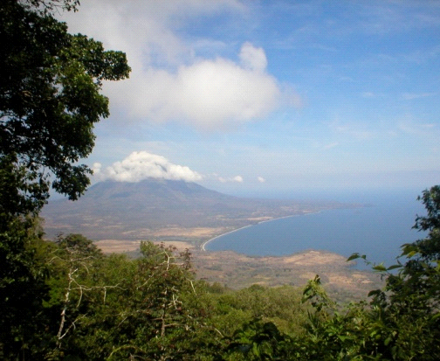
Nicaraguan Culture

If you are interested in the country’s people and what they do for fun, then you will love their Spanish influences.
Many of its traditions were influenced by European culture but with a mix of American Indian culture as well.
Based on the locations of Nicaragua’s cities, its culture is very strong about folklore, music and religious traditions, similar to Spanish-speaking Latin American communities.
In this picture American Indian culture has influenced its people.
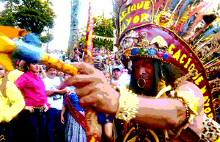
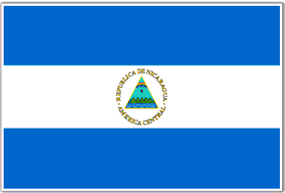

Me País se llama Nicaragua.
Està en Centró América
Las persona se llaman nicaraguences
Una persona famosa de mi país es Jessica Aguilera, que compitió en los Juegos Olímpicos de Beijing 2008.
El día de indepencia de mi país el 15 de Septiembre 1821.
Un dato histórico interesante que hoy volcanos y erupciones en los Pacific Lowlands.

Nicaragua
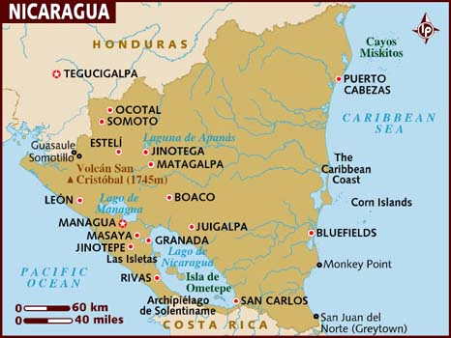

Mitchell Lising
Spanish- 3

